|  |  |
| --- | --- |
| ***C:\Documents and Settings\Administrator\Desktop\Letterheads2.png*** | C:\Documents and Settings\Administrator\Desktop\Letterheads2.png |

|  |  |  |
| --- | --- | --- |
| **InfoConnect Sdn Bhd**  **(302995-V)**  **Docuflo (MSC) Sdn Bhd**  **(735174-H)**  **Corporate Office**  15-B, Jalan SS 22/23, Damansara Jaya, 47400 Petaling Jaya,  Selangor Darul Ehsan  *Tel: +603 7722 2001*  *Fax: +603 7722 1994*  . | |  | | --- | | Version Number: V1.5 | |
| **PT. Asuransi Jiwa BCA**  **User Requirements Specification (URS)**   * **Phase 2** * **SPAJ Module** |
|  | |  |  | | --- | --- | | Date Prepared | : 09/05/2016 | | Author | : Andy Phan Chee Seng | |  |  | |  |  | |
| **PROPRIETARY NOTE**: *This document remains the property of* *InfoConnect Sdn Bhd. All information herein is confidential. Neither the whole nor any part of this document may be used, reproduced or transmitted, in any form or by any means, electronic or mechanical, including recording or the use of any information storage and retrieval system, without the prior written consent of InfoConnect Sdn Bhd.* | | |

**SIGNATURES PAGE:**

We, the undersigned below, mutually agreed and accepted the contents of this User Requirements Specification (URS) for the PT. Asuransi Jiwa BCA, to be provided by InfoConnect Sdn Bhd.

**VENDOR SIGNOFF – INFOCONNECT**

|  |  |
| --- | --- |
| Prepared By | Reviewed By |
|  |  |
| Name: Andy Phan Chee Seng  Title: Vice President  Date: |  |

**CUSTOMER SIGNOFF – BCA LIFE**

|  |  |  |
| --- | --- | --- |
| Reviewed/Accepted By: | | |
|  |  |  |
| Name: Vera Lisnan  Title: In Branch  Date: | Name: Maria Junita  Title: Sales Support  Date: | Name: Eko Logito  Title: Sales Support Head  Date: |
|  |  |  |
| Name: Eko Mungki  Title: New Business  Date: | Name: Susilowati  Title: New Business Head  Date: | Name: Daniel Kuhon  Title: UW  Date: |
|  |  |  |
| Name: Monalita Koswanto  Title: UW Head  Date: | Name: Torsy Siahaan  Title: OSCM Head  Date: | Name: Laksmi Dewi  Title: Operation Division Head  Date: |
|  |  |  |
| Name: Irene Poernomo  Title: BA Head  Date: | Name: Gilbert Leman  Title: IT Division Head  Date: | Name: Tony  Title: In Branch Division Head  Date: |

|  |  |
| --- | --- |
| Approved By | |
|  |  |
| Name: Yannes Chandra  Title: Director  Date: | Name: Honggo Djojo  Title: Director  Date: |

**AMENDMENT HISTORY:**

The table below contains a history of the changes made to URS of this project name. The version number corresponds to control number as indicated in front page.

|  |  |  |  |  |
| --- | --- | --- | --- | --- |
| **No.** | **Description of Amendment** | **Author** | **Version No.** | **Version Date** |
| 1 | Initial draft release | Andy Phan | 1.0 | 09/05/16 |
| 2 | Review 1 | Andy Phan | 1.1 | 31/05/16 |
| 3 | Revision on comments by Torsi | Andy Phan | 1.2 | 08/06/16 |
| 4 | Revision   * Page 11 (Change Information terms to B. Indonesia) * Page 24 (Changes to Penerima Manfaat) * Page 29 (Include Standard Form pop up for Question 10) | Andy Phan | 1.3 | 14/06/16 |
| 5 | Revision   * Change Submission time from 5 days to 30 days | Andy Phan | 1.4 | 20/06/16 |
| 6 | Revision   * Change supporting document format from TIFF to JPG | Andy Phan | 1.5 | 21/06/16 |

**TABLE OF CONTENTS**

1 INTRODUCTION 6

1.1 OBJECTIVE 6

1.2 project Scope 6

1.3 abbreviations 7

1.4 study approach 7

2 USER REQUIREMENTS 8

2.1 Process flow OVERVIEW 8

2.2 design OVERVIEW 9

2.3 SPAJ module OVERVIEW 10

2.3.1 eApplication listing 10

2.3.2 SPAJ Listing 11

2.3.3 Submitted SPAJ Listing 12

2.4 creation of spaj 13

2.5 To Complete SPAJ details 15

2.5.1 Data calon pemegang polis 15

2.5.2 data calon tertanggung 19

2.5.3 Data perusahaa / badan hukum 22

2.5.4 data calon penerima manfaat 24

2.5.5 Data pembayaran 26

2.5.6 Data kesehatan 27

2.6 forms generation and verification 30

2.7 To capture proof of identification 32

2.8 To obtain e-signature from respective parties 33

2.9 To SPAJ Number to the application 37

2.10 eSubmission MPOS client 38

2.11 eSubmission mpos server 40

2.12 mpos server integration to core system 41

**LIST OF TABLES**

Table 1: Abbreviations 7

***Table 2: List of users*** 7

1. INTRODUCTION
   1. OBJECTIVE

The objective of the SPAJ module is to capture all the information from the customer when they are ready to proceed with purchasing the product recommended by the agent. All these data captured will be populated into the SPAJ PDF digital copy and customer signature will be capture electronically by signing on the iPAD.

A sets of XML data on the submission will be submitted to the MPOS server, where it will transfer to the backend core system.

* 1. project Scope

This document covers the features and functionality of the SPAJ Module that will be accessed from the Main Menu and also from the Sales Activities Management Module as discussed during the session of requirement elicitation that specifically built for BCA Life.

* 1. abbreviations

Below is a list of abbreviations used in this document.

|  |  |  |
| --- | --- | --- |
| **No** | **Abbreviation** | **Description** |
| 1 | MPOS | Mobile Point Of Sales |
| 2 | URS | User Requirement Specification |
| 3 | UAT | User Acceptance Testing |
| 4 | CFF | Customer Fact Find |
| 5 | RPF | Risk Profiling |
| 6 | FNA | Financial Needs Analyst |
| 7 | SAM | Sales Activities Management |

Table 1: Abbreviations

* 1. study approach

A series of user requirement study sessions has been conducted with the users of BCA Life. The users who have been involved in the user requirement study sessions are as follows:

|  |  |  |
| --- | --- | --- |
| **No** | **Name** | **Department** |
| 1. | Pak Yusuf Sutarko | PA |
| 2. | Pak Julius Luthena | IT/PM |
| 3. | Ibu Vera Lisnan | In-Branch |
| 4. | Pak Eko | In-Branch |
| 5. | Pak Tony Liauw | In-Branch |
| 6. | Pak Torsy | Operations |
| 7. | Pak Daniel | Operations |
| 8. | Pak Mungki | Operations |

***Table 2: List of users***

1. USER REQUIREMENTS
   1. Process flow OVERVIEW

Below are the ways SPAJ module can be accessed.

**Direct Access from Main Menu**

SPAJ can be accessed from the Main Menu

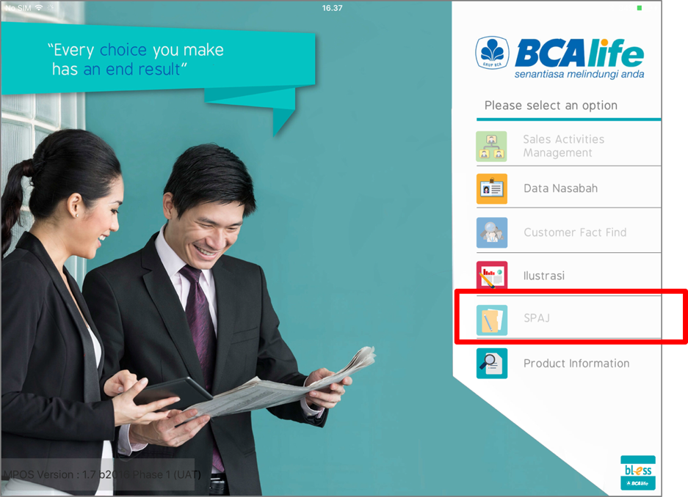



But the control is just limited to View Only.

**Access from Sales Activities Management Module**

New SPAJ can only be created from the Sales Activities Management (SAM) module. Agent must create the Customer record first, do a product recommendation and then proceed with the Sales Illustration presentation and finally proceed with the SPAJ creation.

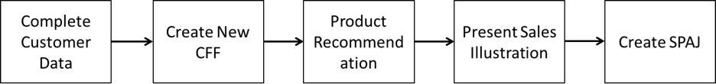

* 1. design OVERVIEW

This section show the color theme requirement for SPAJ Module.

|  |  |
| --- | --- |
| **Module** | **Color Theme and Code** |
| SPAJ |  |

* 1. SPAJ module OVERVIEW

This section show the list of requirements captured for SPAJ Module.

SPAJ Module divided into 3 main listing page.

* + eApplication Listing (Listing of all newly created SPAJ, before submission)
  + SPAJ Listing (Listing of all the SPAJ that are confirmed and are ready for submission)
  + Submitted
    1. eApplication listing

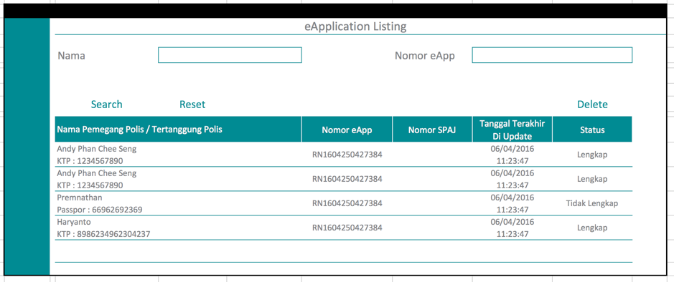

Features available in eApplication Listing page

* Search by Nama and Nomor eApp
* Sorting
  + By default is sorted by Tanggal Terakhir Di Update
  + Nama (by Tap)
  + Nomor eApp (by Tap)
  + Nomor SPAJ (no value will be populated as SPAJ number have not been assigned)
  + Status (by Tap)

Status is use to show if the SPAJ is completely filled up and ready for submission.

* Lengkap (all mandatory information is captured and is ready for submission)
* Tidak Lengkap (some mandatory information not complete)
  + 1. SPAJ Listing

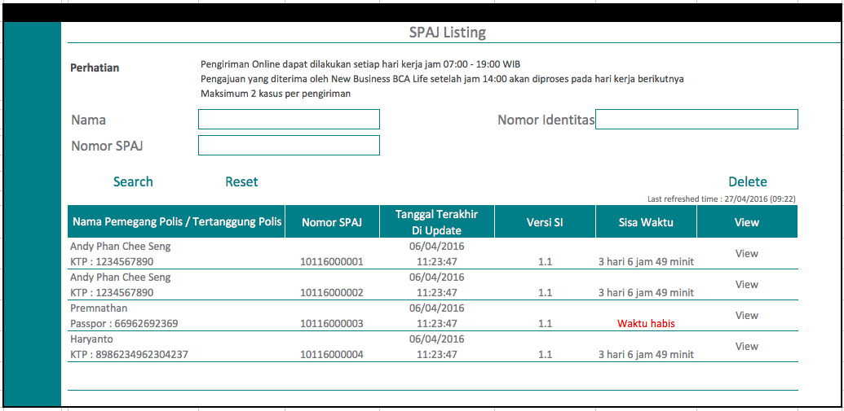

Features available in SPAJ Listing page

* Search by Nama, Nomor SPAJ and Nomor Identitas
* Sorting
  + By default is sorted by Tanggal Terakhir Di Update
  + Nama (by Tap)
  + Nomor SPAJ (by Tap)
  + Sisa Waktu (by Tap)
* Delete SPAJ

Sisa Waktu is the time remaining for the agent to submit the SPAJ to the MPOS server. Once the time remaining expired, which it will show “Waktu habis”, SPAJ will be void. By default, the time is set to 30 days.

Before submission the following will be validated.

|  |  |  |  |
| --- | --- | --- | --- |
| No. | Validation | Remarks | Control |
| 1. | Product Version | Any changes to the product will create a new version number, during product setup, there will be a flag to indicate the changes required upgrade or can bypass upgrade. | If Product version required upgrades, system will disable submission for that case with the obsolete product attached. |
| 2. | SPAJ Form | All changes to the SPAJ forms required upgrade. | If SPAJ version number is not the same, system will disable submission. |
| 3. | Health Questionnaires Form | All changes to the Health Questionnaires forms required upgrade. | If Health Questionnaires Form version number is not the same, system will disable submission. |

* + 1. Submitted SPAJ Listing

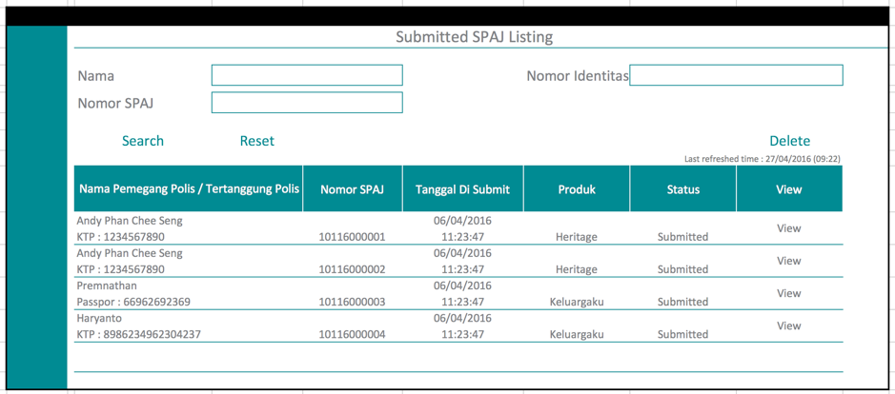

Features available in Submitted SPAJ Listing page

* Search by Nama, Nomor SPAJ and Nomor Identitas
* Sorting
  + By default is sorted by Tanggal Di Submit
  + Produk (by Tap)
  + Status (by Tap)
* Delete SPAJ
  1. creation of spaj

New SPAJ can only be created from the Sales Activities Management module. Below are the process flow.

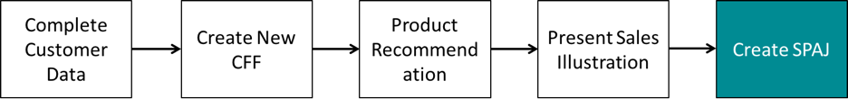

This URS will record the requirements on the new SPAJ creation.

It will start with the SPAJ Checklist.

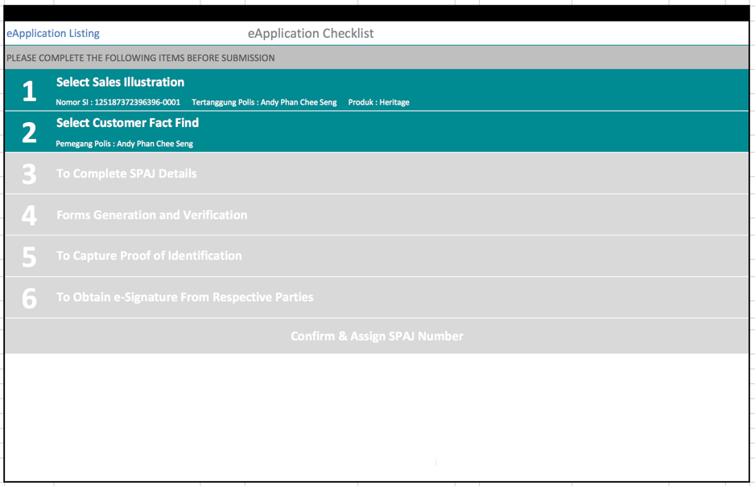

There are total 6 steps the agent need to complete before submission.

1. Select Sales Illustration
   1. This is done during Sales Activities Management stage, and it will be auto selected in the SPAJ module.
2. Select Customer Fact Find
   1. This is also done during Sales Activities Management stage, it will be auto selected based on the Pemegang Polis information.
3. To Complete SPAJ Details
   1. This is the section will capture the following:
      1. Data Calon Pemegang Polis (auto populated from Data Nasabah)
      2. Data Calon Tertanggung (auto populated from Data Nasabah)
      3. Perusahaan / Badan Hukum
      4. Data Calon Penerima Manfaat
      5. Ilustrasi (auto populated from SI)
      6. Data Pembayaran Premi
      7. Data Kesehatan
4. Forms Generation and Verification
   1. All data captured will be populated into the PDF digital SPAJ form.
5. To Capture Proof of Identification
   1. To snap pictures of the supporting document using the iPAD camera
6. To Obtain the e-Signature from Respective Parties

* Each completed checklist will be highlighted.
* Once the e-Signature is captured completely, the “Confirm & Assign SPAJ Number” will be enabled.
* SPAJ number will only be issued when the “Confirm & Assign SPAJ Number” button is click.

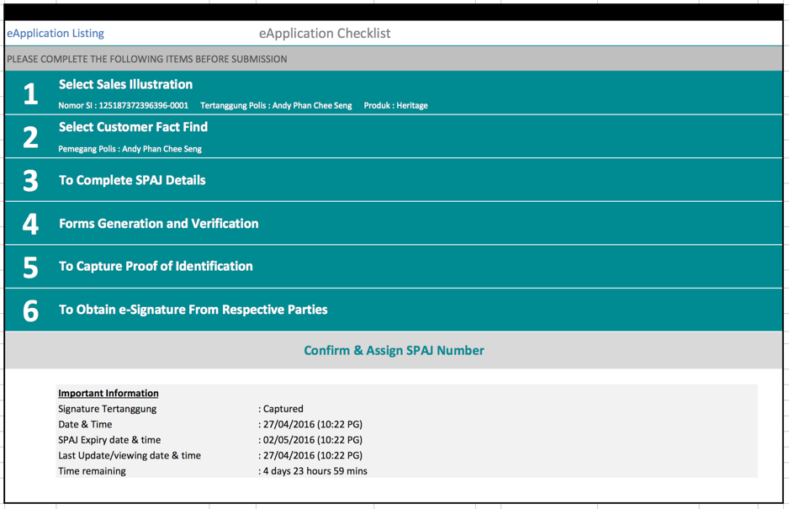

* 1. To Complete SPAJ details

This module capture the following:

* 1. Data Calon Pemegang Polis (auto populated from Data Nasabah)
  2. Data Calon Tertanggung (auto populated from Data Nasabah)
  3. Perusahaan / Badan Hukum
  4. Data Calon Penerima Manfaat
  5. Ilustrasi (auto populated from SI)
  6. Data Pembayaran Premi
  7. Data Kesehatan
     1. Data calon pemegang polis

This forms will captured the Data Calon Pemegang Polis.

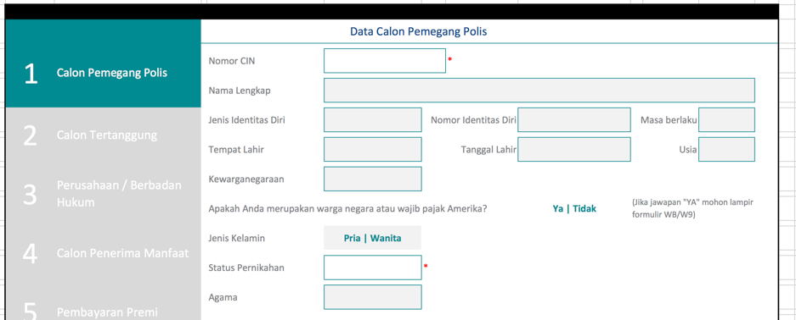

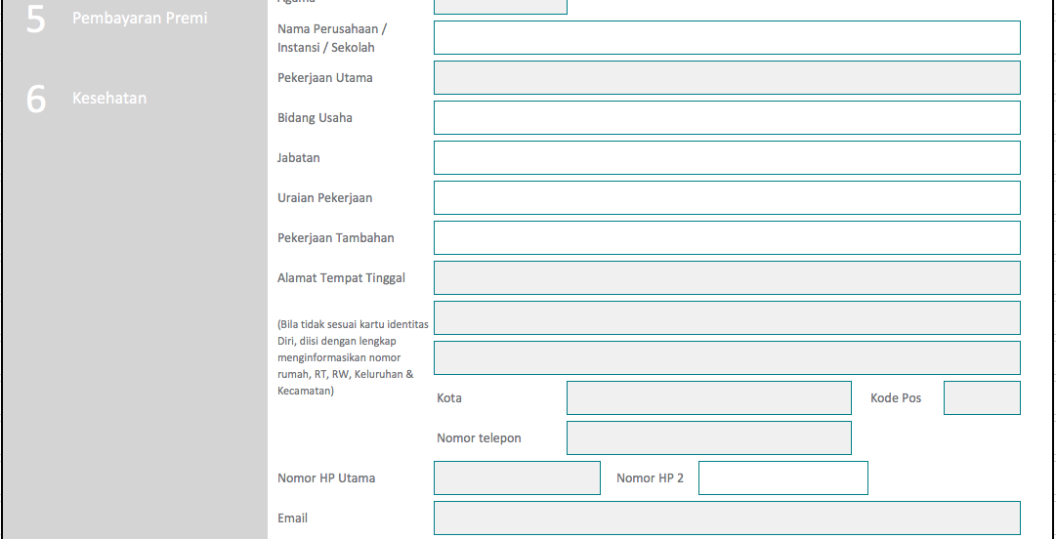

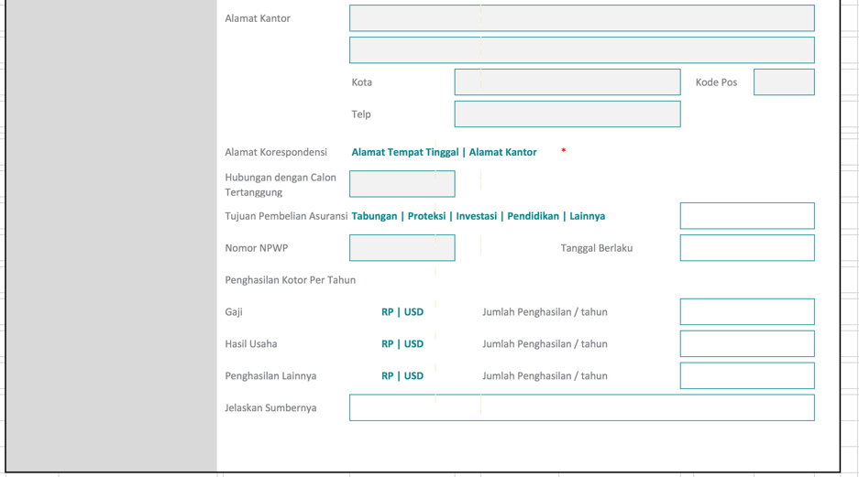

|  |  |  |  |  |
| --- | --- | --- | --- | --- |
| Field | Auto Populate | Allowed Editing | Mandatory | Validation |
| Nomor CIN |  |  | Yes |  |
| Nama Lengkap | Yes | No | Yes |  |
| Jenis Identitas Diri | Yes | No | Yes |  |
| Nomor Identitas Diri | Yes | No | Yes |  |
| Masa berlaku | Yes | No | Yes |  |
| Tempat Lahir | Yes | No |  |  |
| Tanggal Lahir | Yes | No | Yes |  |
| Usia | Yes | No |  | Auto calculated |
| Kewarganegaraan | Yes | No | Yes |  |
| Jenis Kelamin | Yes | No | Yes |  |
| Status Pernikahan |  |  |  | Dropdown |
| Agama | Yes | No |  |  |
| Pekerjaan Utama | Yes | Yes |  |  |
| Bidang Usaha |  |  |  |  |
| Jabatan |  |  |  |  |
| Uraian Pekerjaan |  |  |  |  |
| Pekerjaan Tambahan |  |  |  |  |
| Alamat Tempat Tinggal | Yes | Yes | Yes |  |
| Kota | Yes | Yes | Yes |  |
| Kode Pos | Yes | Yes | Yes |  |
| Nomor telepon | Yes | Yes |  |  |
| Nomor HP Utama | Yes | Yes | Yes |  |
| Nomor HP 2 | Yes | Yes |  |  |
| Email | Yes | Yes |  |  |
| Alamat Kantor | Yes | Yes |  |  |
| Kota | Yes | Yes |  |  |
| Kode Pos | Yes | Yes |  |  |
| Telepon | Yes | Yes |  |  |
| Alamat Korespondensi |  |  |  | Alamat Tempat Tinggal  Alamat Kantor |
| Hubungan dengan Calon Tertanggung | Yes | No |  |  |
| Tujuan Pembelian Asuransi |  |  |  | Tabungan  Proteksi  Investasi  Pendidikan  Lainnya |
| Nomor NPWP | Yes | Yes |  |  |
| Tanggal Berlaku |  |  |  |  |
| Gaji |  |  |  | RP  USD |
| Jumlah Penghasilan / tahun |  |  |  |  |
| Hasil Usaha |  |  |  | RP  USD |
| Jumlah Penghasilan / tahun |  |  |  |  |
| Penghasilan Lainnya |  |  |  | RP  USD |
| Jumlah Penghasilan / tahun |  |  |  |  |
| Jelaskan Sumbernya |  |  |  |  |
|  |  |  |  |  |

* + 1. data calon tertanggung

This forms will captured the Data Calon Tertanggung.

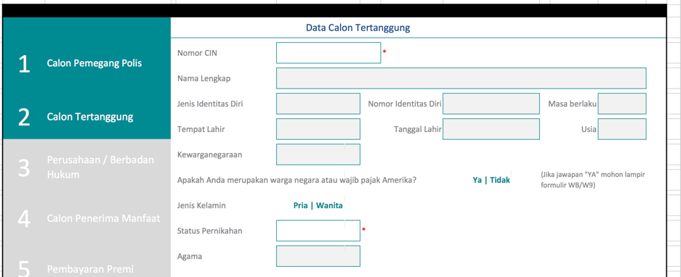

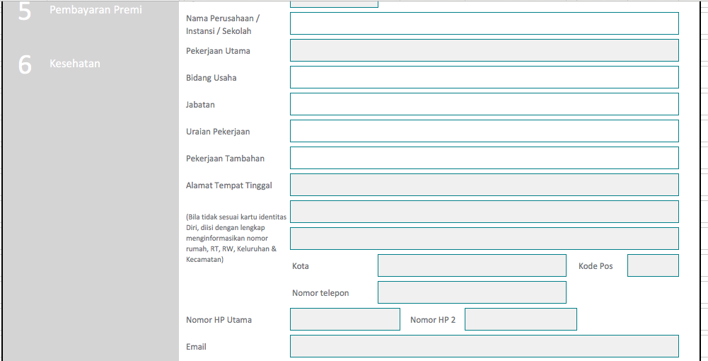

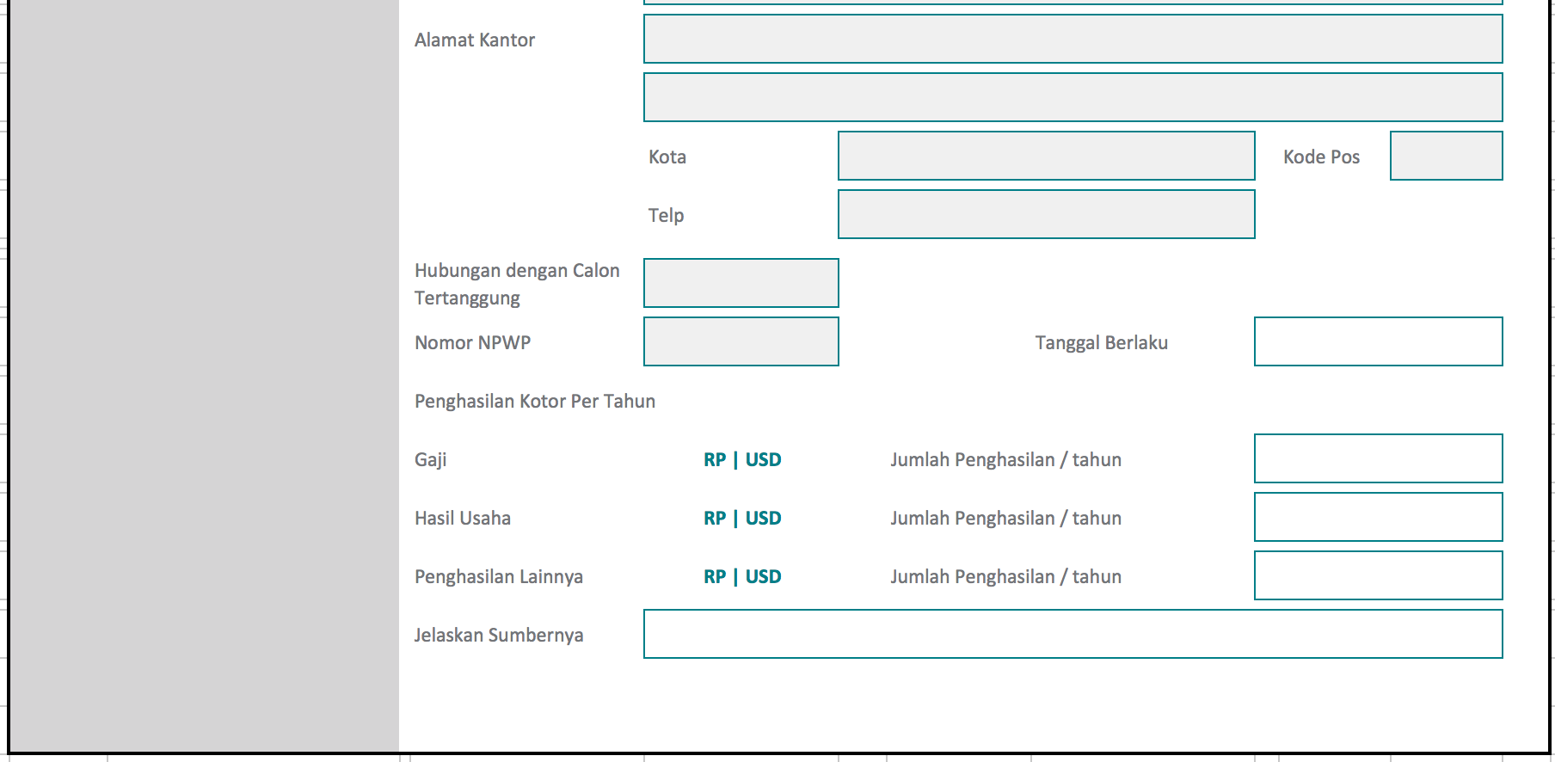

|  |  |  |  |  |
| --- | --- | --- | --- | --- |
| Field | Auto Populate | Allowed Editing | Mandatory | Validation |
| Nomor CIN |  |  | Yes |  |
| Nama Lengkap | Yes | No | Yes |  |
| Jenis Identitas Diri | Yes | No | Yes |  |
| Nomor Identitas Diri | Yes | No | Yes |  |
| Masa berlaku | Yes | No | Yes |  |
| Tempat Lahir | Yes | No |  |  |
| Tanggal Lahir | Yes | No | Yes |  |
| Usia | Yes | No |  | Auto calculated |
| Kewarganegaraan | Yes | No | Yes |  |
| Jenis Kelamin | Yes | No | Yes |  |
| Status Pernikahan |  |  |  | Dropdown |
| Agama | Yes | No |  |  |
| Pekerjaan Utama | Yes | Yes |  |  |
| Bidang Usaha |  |  |  |  |
| Jabatan |  |  |  |  |
| Uraian Pekerjaan |  |  |  |  |
| Pekerjaan Tambahan |  |  |  |  |
| Alamat Tempat Tinggal | Yes | Yes | Yes |  |
| Kota | Yes | Yes | Yes |  |
| Kode Pos | Yes | Yes | Yes |  |
| Nomor telepon | Yes | Yes |  |  |
| Nomor HP Utama | Yes | Yes | Yes |  |
| Nomor HP 2 | Yes | Yes |  |  |
| Email | Yes | Yes |  |  |
| Alamat Kantor | Yes | Yes |  |  |
| Kota | Yes | Yes |  |  |
| Kode Pos | Yes | Yes |  |  |
| Telepon | Yes | Yes |  |  |
| Alamat Korespondensi |  |  |  | Alamat Tempat Tinggal  Alamat Kantor |
| Hubungan dengan Calon Tertanggung | Yes | No |  |  |
| Tujuan Pembelian Asuransi |  |  |  | Tabungan  Proteksi  Investasi  Pendidikan  Lainnya |
| Nomor NPWP | Yes | Yes |  |  |
| Tanggal Berlaku |  |  |  |  |
| Gaji |  |  |  | RP  USD |
| Jumlah Penghasilan / tahun |  |  |  |  |
| Hasil Usaha |  |  |  | RP  USD |
| Jumlah Penghasilan / tahun |  |  |  |  |
| Penghasilan Lainnya |  |  |  | RP  USD |
| Jumlah Penghasilan / tahun |  |  |  |  |
| Jelaskan Sumbernya |  |  |  |  |

* + 1. Data perusahaa / badan hukum

This form will capture the company information. This is only for company case.

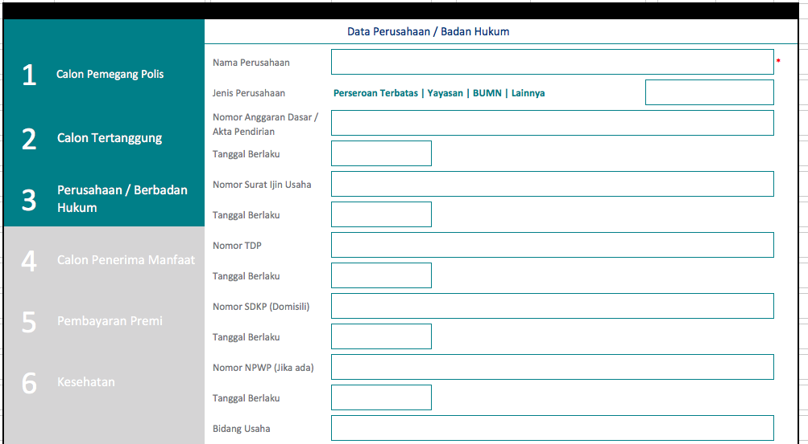

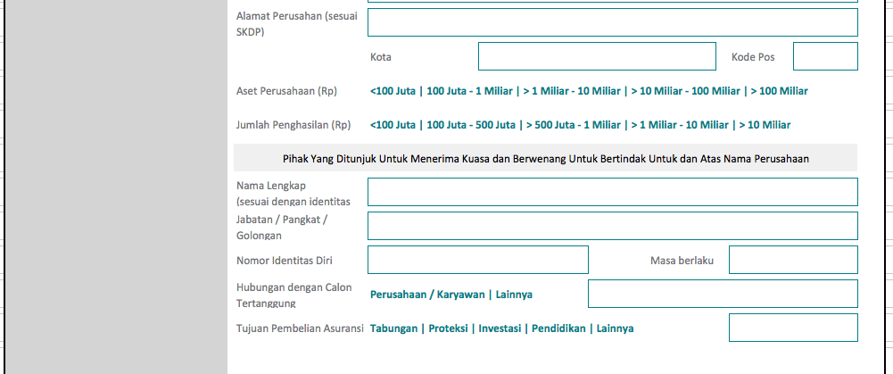

|  |  |  |  |  |
| --- | --- | --- | --- | --- |
| Field | Auto Populate | Allowed Editing | Mandatory | Validation |
| Nama Perusahaan |  |  | Yes |  |
| Jenis Perusahaan |  |  |  | Perseroan Terbatas  Yayasan  BUMN  Lainya |
| Nomor Angarran Dasar / Akta Pendirian |  |  |  |  |
| Tanggal Berlaku |  |  |  |  |
| Nomor Surat Ijin Usaha |  |  |  |  |
| Tanggal Berlaku |  |  |  |  |
| Nomor TDP |  |  |  |  |
| Tanggal Berlaku |  |  |  |  |
| Nomor SDKP (Domisili) |  |  |  |  |
| Tanggal Berklaku |  |  |  |  |
| Nomor NPWP (Jika ada) |  |  |  |  |
| Tanggal Berlaku |  |  |  |  |
| Bidang Usaha |  |  |  |  |
| Alamat Perusahaan (sesuai SKDP) |  |  |  |  |
| Kota |  |  |  |  |
| Kode Pos |  |  |  |  |
| Aset Perusahaan |  |  |  | <100 Juta  100 Juta – 1 Miliar  > 1 Miliar – 10 Miliar  > 10 Miliar – 100 Miliar  > 100 Miliar |
| Jumlah Penghasilan |  |  |  |  |
| Nama Lengkap |  |  | Yes | <100 Juta  100 Juta – 500 Juta  > 500 Juta – 1 Miliar  > 1 Miliar – 10 Miliar  > 10 Miliar |
| Jabatan / Pangkat / Golongan |  |  | Yes |  |
| Nomor Identitas Diri |  |  | Yes |  |
| Hubungan dengan Calon Tertanggung |  |  | Yes | Perusahaan  Karyawan  Lainnya |
| Tujuan Pembelian Asuransi |  |  |  | Tabungan  Proteksi  Investasi  Pendidikan  Lainnya |

* + 1. data calon penerima manfaat

This form capture the Penerima Manfaat information.

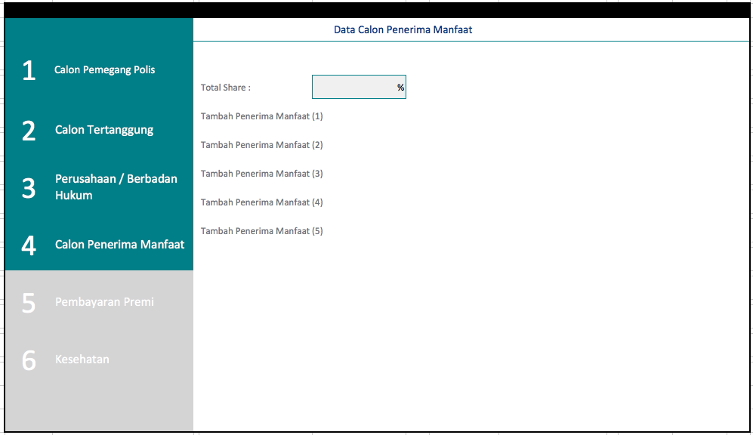

* Mandatory to have 1 Penerima Manfaat.
* A maximum of up to 10 Penerima Manfaat name are allowed.
* Total Share don’t need to be equal to 100%
* Validation : (Nama Lengkap + Jenis Kelamin + Tanggal Lahir) cannot be the same with Pemegang Polis or Tertanggung
* If Pemegang Polis is different from Tertanggung, Pemegang Polis can be Penerima Manfaat.

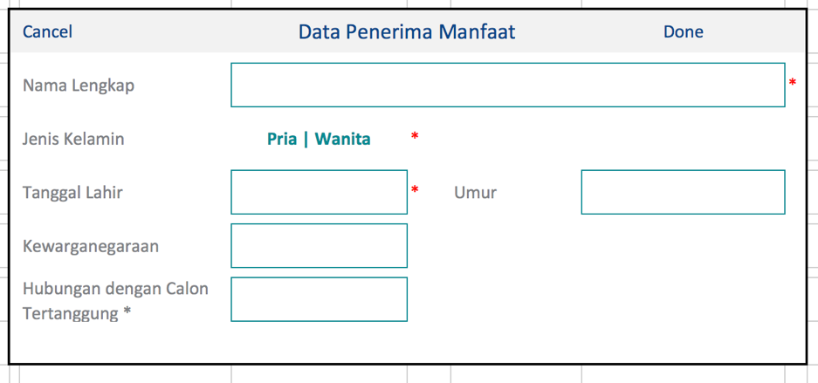

|  |  |  |
| --- | --- | --- |
| Field | Mandatory | Validation |
| Nama Lengkap | Yes |  |
| Jenis Kelamin | Yes |  |
| Tanggal Lahir | Yes |  |
| Umur |  | Auto calculate |
| Kewarganegaraan |  | Nationality dropdown table |
| Hubungan dengan Calon Tertanggung |  | Diri Sendiri  Orang Tua  Anak  Pasangan  Saudara Laki-Laki  Saudara Perempuan  Kakek / Nenek  Cucu  Bibi  Paman  Keponakan Laki-Laki  Keponakan Perempuan  Pekerja  Pemberi Kerja  Lainnya  Ahli Waris  Wali  Kreditor / Debitor  Amal  Ahli Waris Hukum |

* + 1. Data pembayaran

This form capture the method and frequency of payment.

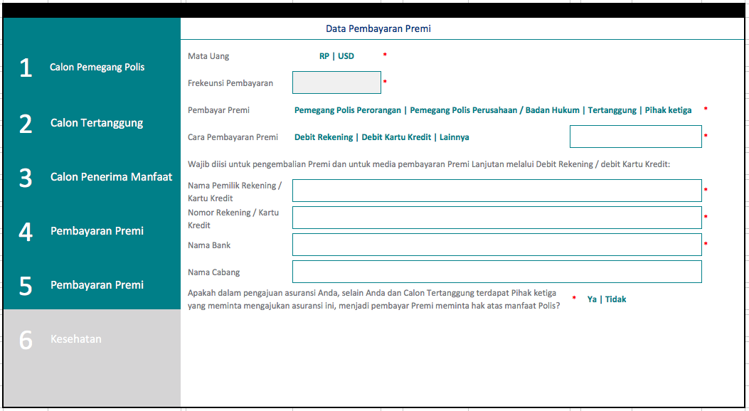

|  |  |  |
| --- | --- | --- |
| Field | Mandatory | Validation |
| Mata Uang |  | Default to “IDR” |
| Frekeunsi Pembayaran | Yes | Auto populated from SI |
| Pembayar premi | Yes | Pemegang Polis Perorangan  Pemegang Polis Perusahaan  Tertanggung  Pihak ketiga |
| Cara Pembayaran Premi | Yes | Autodebet Account  Autodebet Credit Card  Lainnya |
| Nama Pemilik Rekening / Credit Card | Yes | If Cara Pembayaran Premi = Debit Rekening or Debit Credit Card |
| Nomor Rekening / Credit Card | Yes | If Cara Pembayaran Premi = Debit Rekening or Debit Credit Card |
| Nama Bank | Yes | If Cara Pembayaran Premi = Debit Rekening or Debit Credit Card |
| Nama Cabang | Yes | If Cara Pembayaran Premi = Debit Rekening or Debit Credit Card |
| Apakah dalam pengajuan asuransi Anda, selain Anda dan Calon Tertanggung terdapat Pihak ketiga yang meminta mengajukan asuransi ini, menjadi pembayar Premi meminta hak atas manfaat Polis? | Yes | If “Ya” Pop up “Formulir keterangan Tambahan untuk Pihak ketiga” |

* + 1. Data kesehatan

This form will capture the health questionnaires for for both Calon Tertanggung and Calon Pemegang Polis.

|  |  |  |  |
| --- | --- | --- | --- |
| Question No. | Questions | Additional Questions Form | Output PDF Form |
| 1. a. | Tinggi Badan | N/A |  |
| 1. b. | Berat Badan | N/A |  |
| 1. | Adakah berat badan Anda mengalami penurunan atau kenaikan drastis (> 10% dalam 1 (satu) bulan) dalam 6 (enam) bulan terakhir? | Standard Form |  |
| 2. | Apakah Anda merokok dalam 12 (dua belas) bulan terakhir (termasuk rokok elektronik atau produk tembakau lainnya)? | Q2 Smoking Form |  |
| 3. | Apakah Anda memiliki kebiasaan atau pernah menggunakan narkotika, zat adiktif atau obat-obatan lainnya, minum alkohol secara berlebihan? Jika “Ya”, jelaskan jumlah serta frekuensi mengkonsumsinya. Serta jelaskan jika ada riwayat perawatan/mendapat terapi karena hal tersebut? | Q3 Alkohol Form | KUESIONER Alkohol dan Obat Obatan |
| 4. | Apakah Anda memiliki hobi atau sewaktu-waktu melakukan kegiatan yang beresiko tinggi/bahaya atau masih aktif dalam pekerjaan beresiko tinggi (menyelam, panjat tebing, mendaki gunung, terjun payung, paralayang, balap motor/mobil, pertambangan, minyak dan gas bumi, Kelautan, TNI/Polri, penerbangan (selain dari penumpang resmi penerbangan terjadwal))? (Jika jawaban “Ya” mohon melengkapi kuesioner yang sesuai hobi/kegiatan/pekerjaan tersebut dan dilampirkan bersama SPAJ ini). | Q4 Hobi Form  Menyelam – **Q4 Menyelam**  Panjat Tebing / Mendaki Gunung – **Q4 Mendaki Gunung**  Paralayang – **Q4 Terbang Layang**  Balap Motor / Mobil – **Q4 Olahraga Balap**  Pertambangan **– Q4 Pertambangan**  Anggkatan Bersenjata – **Q4 Angkatan Bersenjata**  Penerbangan – **Q4 Penerbangan** | KUESIONER Menyelam  KUESIONER Daki Gunung & Panjat Tebing  KUESIONER Terbang Layang  KUESIONER Olahraga Balap  KUESIONER Tambang Minyak Gas  KUESIONER Angkatan Bersenjata  KUESIONER Penerbangan |
| 5. | Apakah Anda dalam 12 bulan terakhir ini/mendatang Anda pernah/memiliki rencana bepergian/tinggal di luar negeri? Jika “Ya”, jelaskan kapan waktu bepergiannya, negara tujuan, lama tinggal, serta kepentingannya. | Q5 Perjalanan dari ke Luar Negeri Form | KUESIONER Perjalanan dari ke Luar Negeri |
| 6. | Apakah Anda pernah/sedang menderita penyakit atau menjalani pemeriksaan/perawatan, pengobatan, operasi untuk penyakit/kelainan di bawah ini: |  |  |
| a. | Gangguan fungsi/sistem penglihatan dan gangguan pada mata lainnya? | Q6 Standard Disease Form |  |
| b. | Gangguan fungsi/sistem pada Telinga, Hidung, Tenggorokan (THT)? | Q6 Standard Disease Form |  |
| c. | Gangguan fungsi/sistem Pernapasan, Paru-paru, Asma, Bronkitis, Tuberkulosis, Batuk Darah dan lainnya? | Q6 Ganguan Pernapasan Form | KUESIONER Gangguan Nafas |
| d. | Gangguan fungsi/sistem Jantung dan Pembuluh Darah, Nyeri Dada, Serangan Jantung, Demam, Jantung, Rematik, Tekanan Darah Tinggi (Hipertensi)/Rendah, (Hipotensi), Hiperkolesterol, Penyempitan/Penyumbatan Pembuluh Darah Otak dan lainnya? | Nyeri Dada – **Q6 Nyeri Dada Form**  Tekanan Darah Tinggi – **Q6 Tekanan Darah Tinggi Form** | KUESIONER Nyeri Dada (Jantung)  KUESIONER Tekanan Darah Tinggi |
| e. | Gangguan fungsi/sistem Pencernaan & Organ dalam Perut/Lambung, Maag, Hernia, Hepatitis dan lainnya? | Q6 Gangguan Pencernaan Form | KUESIONER Gangguan Pencernaan |
| f. | Gangguan fungsi/sistem Saraf dan Otot, Vertigo, Stroke, Sering Pusing atau Pingsan, Epilepsi (kejang), Kelumpuhan, Kesemutan, Baal, Gangguan Kejiwaan dan lainnya? | Q6 Epilepsi Form | KUESIONER Epilepsi (Epilepsi) |
| g. | Gangguan fungsi/sistem Hati dan Pankreas, Kencing Manis (Diabetes Melitus), Batu Empedu, Tumor Hati, penyakit Limpa dan lainnya? | Q6 Diabetes | KUESIONER Diabetes (Kencing Manis) |
| h. | Gangguan fungsi/sistem Kemih, Batu Ginjal, Gangguan Prostat, Gagal Ginjal, Organ Kelamin dan penyakit akibat hubungan seksual? | Standard Form |  |
| i. | Gangguan fungsi/sistem Tulang, Otot, Sendi, Kulit? | Q6 Tulang Belakang Form | KUESIONER Gangguan Tulang Belakang |
| j. | Gangguan fungsi/sistem Kelenjar dan Darah, Kelenjar Gondok, Kelenjar Getah Bening, Gangguan Hormon, Hemofilia, Anemia, Thalassemia, Leukemia? | Q6 Kelenjar Gondok Form | KUESIONER Kelenjar Gondok (Thyroid) |
| k. | Gangguan fungsi/sistem Kekebalan Tubuh, HIV/AIDS atau segala gejala yang berhubungan dengan AIDS (demam, diare kronis, penurunan berat badan yang tidak diketahui penyebabnya), Malaria, Lupus dan lainnya? | Standard Form |  |
| l. | Gangguan fungsi Pertumbuhan Sel, Tumor, Kista, Kanker, Benjolan pada permukaan kulit atau pertumbuhan abnormal lainnya? | Q6 Tumor | KUESIONER Tumor (Kanker) |
| m. | Gangguan Kesehatan lainnya yang tidak/belum dinyatakan diatas termasuk namun tidak terbatas pada kelainan bentuk tubuh, kelainan/cacat fisik, kelainan/cacat bawaan dan lainnya? | Standard Form |  |
| 7. | Apakah Anda telah memiliki atau sedang mengajukan pertanggungan Asuransi Jiwa, kecelakaan, kesehatan, pemulihan polis? Serta apakah pengajuan Anda pernah ditolak / ditangguhkan/dikenakan ekstra Premi diubah dalam bentuk apapun oleh perusahaan Asuransi Jiwa? | Q7 Other Insurance Coverage Form |  |
| 8. | Apakah Anda pernah mengajukan klaim ke perusahaan Asuransi Jiwa? Jika “Ya, mohon jelaskan alasannya. | Standard Form |  |
| 9. | Apakah Anda pernah mendapatkan atau bermaksud menjalani pemeriksaan kesehatan diagnostik, seperti Sinar-X, USG, CT-scan, MRI, EKG, Treadmill, pemeriksaan darah, pemeriksaan urin, dan lain-lain? | Standard Form |  |
| 10. | Khusus Calon Tertanggung anak-anak (usia 5 (lima) tahun): | Standard Form |  |
| 11. | Pertanyaan khusus untuk wanita: |  |  |
| a. | Apakah Anda sedang hamil? | Q11 Kehamilan Form | KUESIONER Kehamilan |
| b. | Adakah komplikasi pada kehamilan termasuk persalinan secara sectio caesaria yang dilakukan karena menderita suatu penyakit (Darah Tinggi, Hepatitis, Diabetes dan lain-lain)? | Standard Form |  |
| c. | Apakah Anda mempunyai kelainan payudara/organ kewanitaan lainnya termasuk haid yang tidak teratur? Jika “Ya” jelaskan nama kelainan atau komplikasi dan nama dokter yang merawat pada kolom (Siapa, Apa, Kapan, Dimana, Pengobatan yang dilakukan, Bagaimana). | Standard Form |  |
| d. | Apakah Anda pernah melakukan pemeriksaan Pap Smear dalam 1 (satu) tahun terakhir? Jika “Ya” jelaskan bagaimana hasilnya dan kapan dilakukan pemeriksaan  tersebut? | Standard Form |  |
| 12. | Apakah ada anggota keluarga Anda (orang tua, anak, saudara kandung) yang menderita/dinyatakan terdiagnosa mengidap kelainan Jantung Koroner, Stroke, Kencing Manis (Diabetes Melitus), Kanker atau penyakit keturunan lainnya? | Standard Form |  |

**Additional Health Questionnaires Forms**

Please refer to attached Additional forms

* 1. forms generation and verification

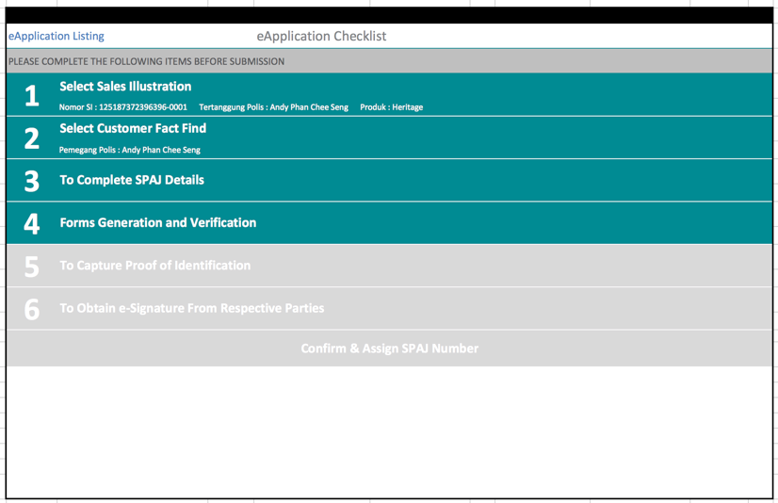

System will populate all data captured into the SPAJ Forms.

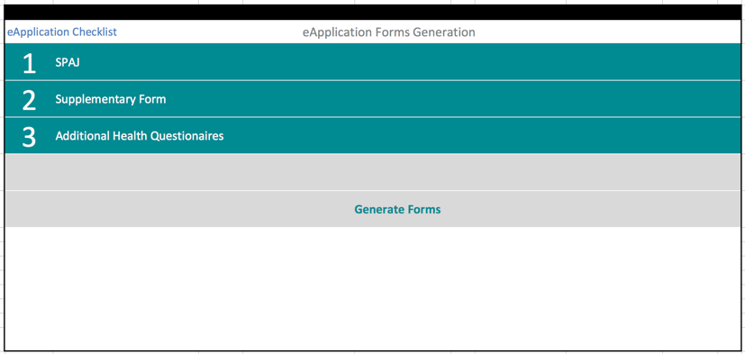

|  |  |  |
| --- | --- | --- |
| Category | Form Name | Version |
| SPAJ | SPAJ | OP / NB / 0104 / 031602 |
| Additional Health Questionaires | KUESIONER Alkohol dan Obat Obatan | OP/UW/0101/011501 |
|  | Kuesioner_Gangguan_Nafas | OP/UW/0108/121401 |
|  | Kuesioner_Nyeri_Dada | OP/UW/0114/121401 |
|  | Kuesioner_Tekanan_Darah_Tinggi | OP/UW/0112/121401 |
|  | Kuesioner_Gangguan_Pencernaan | OP/UW/0107/121401 |
|  | Kuesioner_Epilepsi | OP/UW/0106/121401 |
|  | Kuesioner_Diabetes | OP/UW/0105/121401 |
|  | Kuesioner_Gangguan_Tulang_Belakang | OP/UW/0110/121401 |
|  | Kuesioner_Kelenjar_Gondok (Thyroid) | OP/UW/0122/011501 |
|  | Kuesioner_Tumor | OP/UW/0120/121401 |
|  | KUESIONER Kehamilan | OP/UW/0111/011501 |
|  | KUESIONER Daki Gunung & Panjat Tebing | OP/UW/0104/011501 |
|  | KUESIONER Menyelam | OP/UW/0113/011501 |
|  | KUESIONER Olahraga Balap | OP/UW/0115/011501 |
|  | KUESIONER Penerbangan | OP/UW/0116/011501 |
|  | KUESIONER Pertambangan | OP/UW/0117/011501 |
|  | KUESIONER Terbang Layang | OP/UW/0118/011501 |
|  | KUESIONER TNI atau Polri | OP/UW/0102/011501 |

* 1. To capture proof of identification

This module is to capture the identification proof.

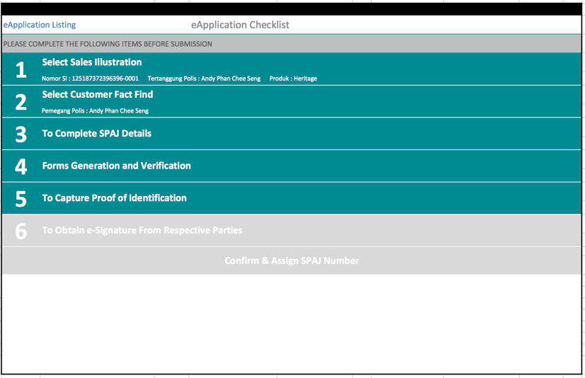

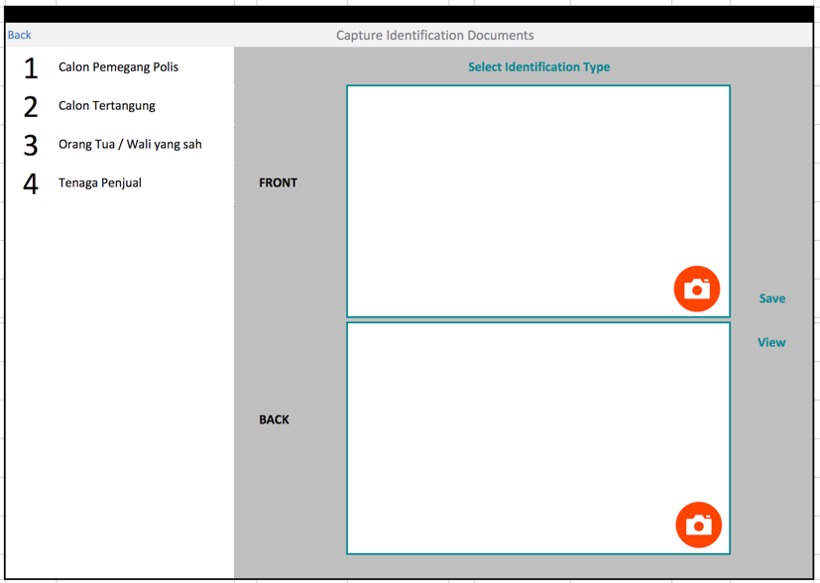

**Document Type List**

|  |  |  |
| --- | --- | --- |
| Document Type | Number of Side | Mandatory Side |
| KTP | Front only | Front |
| Pasport & Kitap | Passport Front & Kitap Front | Both document front |
| Lain-Lain | Front only | Front |

* 1. To obtain e-signature from respective parties

This module is to capture the digital signature of the respective parties.

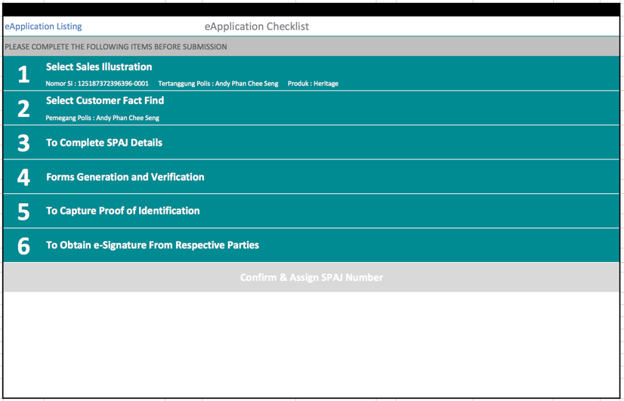

There are 4 parties signature need to be captured based on the following matrix.

|  |  |  |  |
| --- | --- | --- | --- |
| Signature Required | Pemegang Polis = Tertanggung | Pemegang Polis <> Tertanggung | Tertanggung < 21 |
| Pemegang Polis | Yes | Yes | Yes |
| Tertanggung |  | Yes |  |
| Orang Tua / Wali |  |  | Yes |
| Tenaga Penjual | Yes | Yes | Yes |

**Signing Sequence**

|  |  |
| --- | --- |
| **Sequence** | **Signatories** |
| 1 | Pemegang Polis |
| 2 | Tertanggung |
| 3 | Orang Tua / Wali |
| 4 | Tenaga Penjual |

**Control**

* Once Pemegang sign, all forms will be locked from changes.
* SPAJ will be valid for 30 days. After 30 days SPAJ will be void and not submission is allowed.
* After Tenaga Penjual signature is capture, agent is required to input the location the signature is captured.

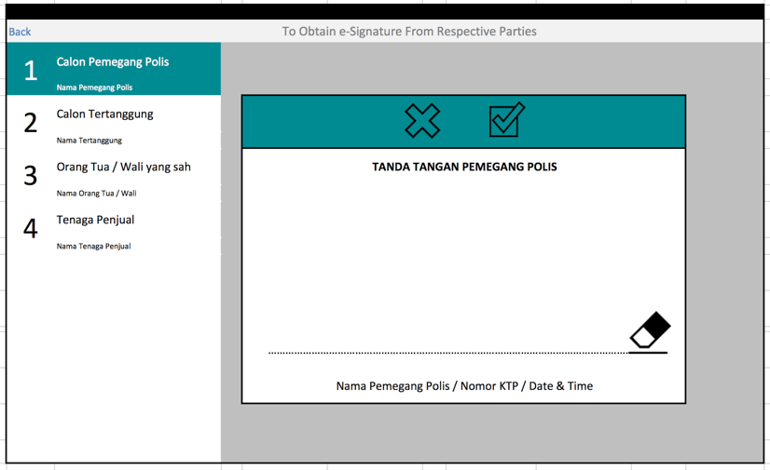

Alert message when Pemegang Polis signature is captured.

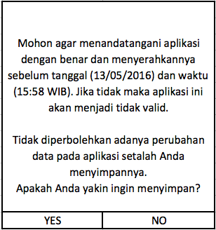

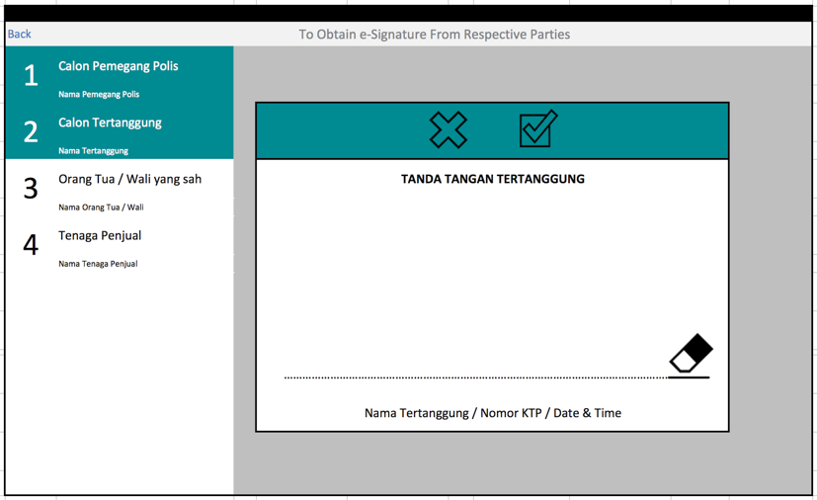

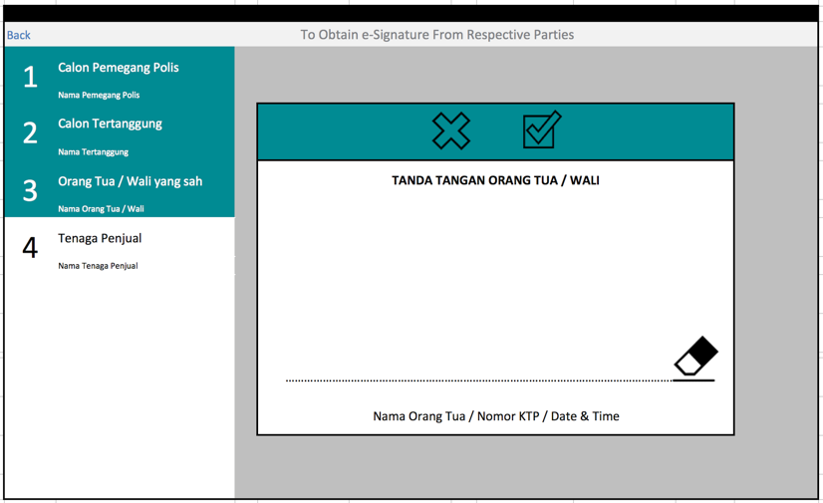

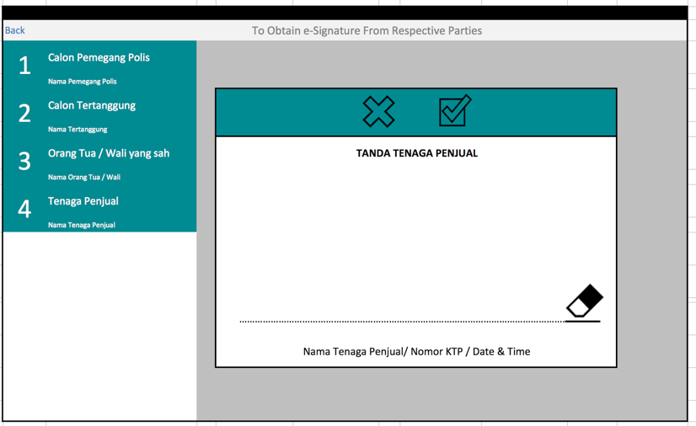

Signature for all parties will be captured only once and it will populate to respective forms based on the table below.

|  |  |  |
| --- | --- | --- |
| Parties | Forms | Remarks |
| Pemegang Polis | SPAJ |  |
| Tertanggung | SPAJ  All Additional Health Questionnaires |  |
| Orang Tua / Wali | SPAJ |  |
| Tenaga Penjual | SPAJ  All Additional Health Questionnaires |  |

* 1. To SPAJ Number to the application

After all the information and signature is captured, the “Confirm & Assign SPAJ Number” button will be enabled.

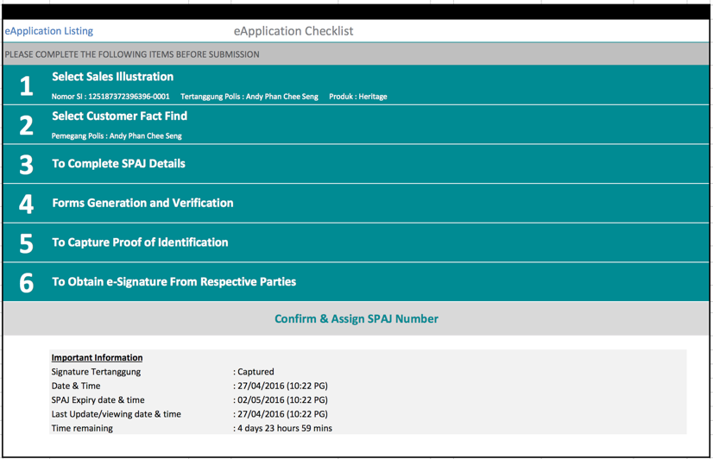

SPAJ Number assignment

* Once all signature captured, the confirm button will be enabled
* SPAJ number will be assign to the case when the “Confirm & Assign SPAJ Number” is press.
  1. eSubmission MPOS client

After SPAJ Number assignment the application will be moved to the SPAJ Listing page, where agent can select and submit to the MPOS Server.

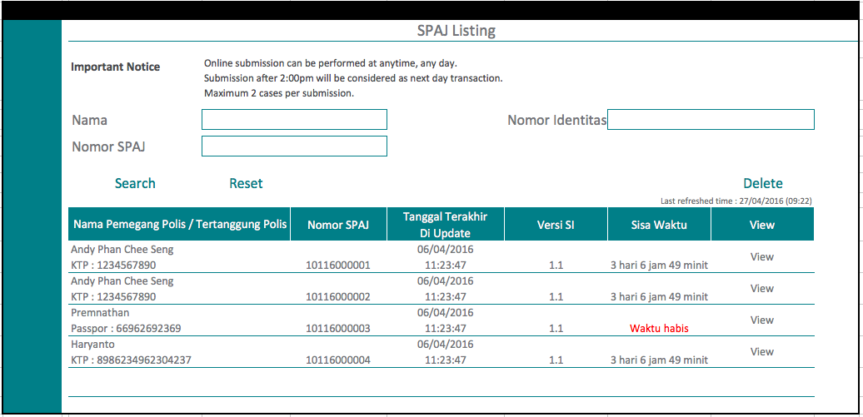

* Each application is only valid for 30 working days. After the date is expired, system does not allowed agent to submit the case.
* MPOS Client will check the SI version with the Server SI version, if the version is not match, system will not allow agent to submit. Agent will have to redo all the application and SI again.
* MPOS Client will submit the following to MPOS Server:
  + SPAJ PDF
  + Sales Illustration PDF
  + Supporting Document in JPG format
  + Additional Questionnaires in JPG format
  + SPAJ XML Data
  + Additional Questionnaires XML Data
  + CFF XML Data

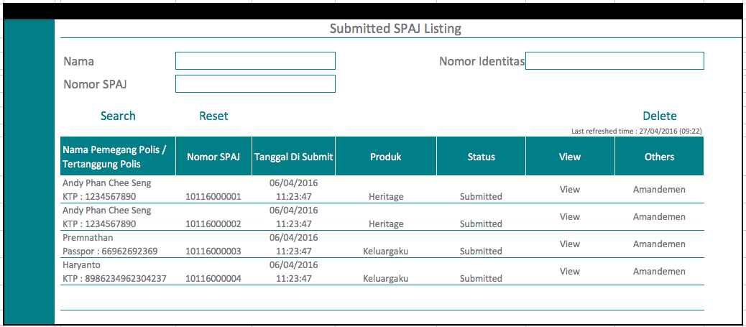

After submission to MPOS Server, the application will be moved to the Submitted SPAJ Listing page. Agent still can view the following:

* SPAJ PDF
* Sales Illustration PDF
* Supporting Document in JPG format
* Additional Questionnaires in JPG format

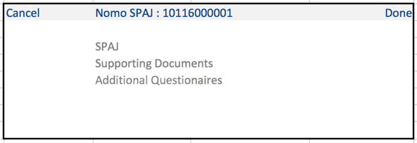

Agent can also submit Amandemen form.

* 1. eSubmission mpos server

MPOS Server will receive the PDF files and images from MPOS Client and return a receipt status to MPOS Client.

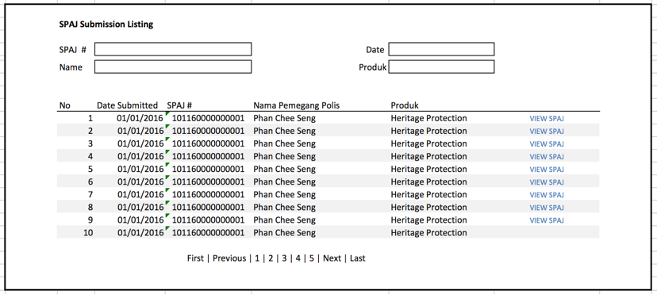

MPOS Server allow the user to view the following:

* SPAJ PDF
* Sales Illustration PDF
* Supporting Document in JPG format
* Additional Questionnaires in JPG format
  1. mpos server integration to core system

MPOS Server will drop the following to the staging folder:

* SPAJ XML Data
* SPAJ PDF
* Supporting Document in JPG format
* Additional Questionnaires in JPG format

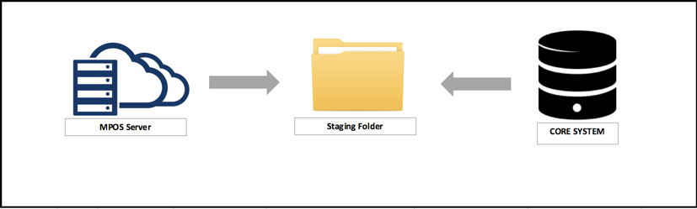

* MPOS Server will create new Folder for each application using the SPAJ Number in the Staging Folder.
* Core System will have to monitor the staging folder and pickup the SPAJ XML Data and all required files.

Below are the New Business Flow integration

* MPOS will submit the SI, SPAJ & Supporting Document Data to NB check common pool.
* Core System will not sent any status to MPOS
* If there is extra premium inputted by the underwriter, Core will sent email to FA & Customer.
* FA will then change the SI according to UW Decision. MPOS will then sent the new SI no to the Core System. Core will then updated the SI number without changing proposal/SPAJ No